Daniel Akoto

Individual Project

COSC 412-101

Design & Implementation

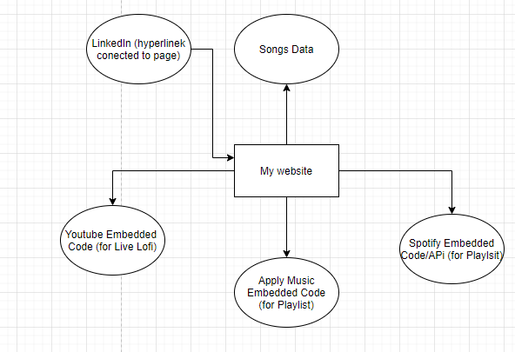

Classes

|  |  |  |  |
| --- | --- | --- | --- |
| Candidate Term | Not a class because | Class name | Class Purpose |
| Splendid |  | App.js | This will be the main class that will control the website functions. Sends and gets information from program and displays onto page. |
| Public | Directory | public | Contains folders that are public, css and image folders |
| Front page |  | Index.ejs | Linked to App.js and when it is called, displays information onto the page. Code on this page is the front page and most of the information will be on this page |
| Contact page |  | Contact.ejs | This page will be the page that contains contact information for listeners to contact me. Also connected to App.js |
| CSS File |  | Main.css | This file focuses on the design of the page and all code here is connected to App.js and sends to the main page. |
| Images | Directory | img | Contains all the songs and pictures for the website |
| Key Frames | This is a function | @keyframe [name] | This will be used to create new animations for the page, located in the Main.css file. |